

Cloud Computing

BITE412L
Course Project Review - I

Cloud Intelligence Platform for Food Supply Chain Loss Prediction and Optimization

Name | Register Number
Arunima | 23BIT0099
Jacob J M | 23BIT0238
Afthab O N | 23BIT0304

Abstract
Food loss and waste remain a persistent problem across agri-food supply chains, driven by inefficient inventory management, poor storage conditions, transportation delays, and the absence of real-time monitoring. Existing research has explored this problem through several disconnected lenses: machine learning models for waste prediction, optimization techniques (PSO-GA, NSGA-II, MILP) for supply chain configuration, IoT-based smart irrigation and temperature control, blockchain frameworks for traceability, and survey-based studies linking AI adoption to supply chain resilience. However, these studies consistently share the same limitations they rely on static, synthetic, or self-reported survey data, address isolated stages of the supply chain rather than the system as a whole, and lack a unified, cloud-based platform capable of continuous monitoring, adaptive prediction, and real-time decision support.
This project proposes a Cloud Intelligence Platform for Food Supply Chain Loss Prediction and Optimization, which integrates IoT sensing, machine learning, and cloud computing to enable end-to-end, real-time monitoring and decision-making across the supply chain. Data from IoT sensors, inventory systems, transportation logs, weather services, and demand patterns will be continuously collected and analyzed to predict food loss, quality degradation, and disruptions, with the platform recommending corrective actions such as inventory redistribution, route planning, and storage adjustments.
The solution will be implemented on Microsoft Azure, using Azure IoT Hub for device connectivity, Azure Blob Storage for data storage, Azure Functions for event-driven processing, Azure Machine Learning for model development and deployment, Azure SQL Database for structured data, Azure API Management for secure integration, Microsoft Entra ID for authentication, Azure Monitor for system health tracking, and Power BI for dashboards. Together, these components aim to reduce food loss, improve operational efficiency, and support sustainable, data-driven supply chain management.

Literature Review
S.No. | Paper | Method | Dataset | Advantages | Limitations | Research Gap
1. | The Development of a Prediction Model Related to Food Loss and Waste in Consumer Segments of Agrifood Chain Using Machine Learning Methods (2024) | Compared CART and Neural Network models to predict Food Waste Percentage (FWP). | Survey Dataset – 365 Romanian respondents, 34 features. Source: Google Forms survey. Link: Not publicly available. | Compares traditional and deep learning models with good predictive performance. | Uses a small, imbalanced dataset based on static survey responses. | Lacks real-time data integration, IoT support, and continuous model updating.
2. | The Food Production–Consumption Chain: Fighting Food Insecurity, Loss, and Waste with Technology (2024) | Conducted a conceptual study using surveys, expert interviews, and technology case studies. | Survey Dataset – 353 participants, 8 industry experts, and multiple technology case studies. Source: Author survey and case studies. Link: Not publicly available. | Provides a comprehensive overview of technology adoption across the food supply chain. | Conceptual study without predictive models and limited to North American survey data. | Lacks a unified cloud platform and real-time predictive analytics for integrated supply chain management.
3. | Agri–Food Supply Chain Design for Perishable Products: Application to Small-Scale Farmers (2025) | Uses a Mixed-Integer Linear Programming (MILP) model to optimize perishable food supply chain operations. | Real-world dataset from 21 suppliers, 6 markets, and 21 warehouses in Atlántico, Colombia (64 scenarios). Source: Case study data. Link: Not publicly available. | Optimizes warehouse allocation while preserving product quality and improving profit. | Assumes fixed supply and demand using only historical data without digital monitoring. | Lacks real-time IoT integration, cloud-based optimization, and live supply chain monitoring.
4. | Digital Transformation of FSC Management Using Blockchain (SLR) (2025) | Conducts a PRISMA-based systematic literature review on blockchain applications in food supply chains. | Secondary dataset comprising 61 research articles from Scopus and Web of Science (2017–2023). Source: Published literature. Link: Not publicly available. | Provides a comprehensive review of blockchain technologies for food supply chains. | Review-based study without implementation or experimental validation. | Lacks an integrated AI-cloud framework with real-time prediction and decision support.
5. | Edge Computing-Oriented Smart Agri Supply Chain with Auction & Fuzzy Neural Networks (2024) | Combines edge computing, encrypted auctions, and a Takagi-Sugeno fuzzy neural network for crop prediction. | Field-collected IoT dataset from 50 farms (~22,500 hours) including crop yield, price, soil moisture, temperature, humidity, and rainfall. Source: Field experiments. Link: Not publicly available. | Improves prediction accuracy while reducing food waste and energy consumption. | Requires expensive IoT infrastructure and is validated only on selected crops. | Lacks a scalable cloud-based platform with real-time optimization and broader supply chain integration.
6. | Optimizing Agri-Food Supply Chain Configuration for Mitigating Both Supply- and Demand-Side Risks (2026) | Uses a hybrid PSO-GA optimization model to configure agri-food supply chains under supply and demand uncertainty. | Synthetic grape supply chain dataset based on Morning Star Company (China) with expert-estimated lead-time data. Source: Adapted from previous research. Link: Not publicly available (available upon request). | Optimizes inventory and transportation while considering both supply-side and demand-side risks. | Uses synthetic offline data and is validated using only a single case study. | Lacks cloud integration, real-time IoT data, and continuous supply chain monitoring.
7. | Multi-Objective Optimization of a Three-Level Sustainable Food Supply Chain: Modeling the Impact of Government Subsidies (2025) | Develops a three-level sustainable food supply chain model using NSGA-II for multi-objective optimization. | Simulated dairy supply chain dataset. Source: Dairy case study. Link: Not publicly available. | Optimizes economic, environmental, and social objectives while incorporating government subsidies. | Uses simulated data with predefined parameters and does not support real-time decision-making. | Lacks cloud computing, IoT integration, and real-time monitoring for adaptive supply chain management
8. | Effective Food Waste Management Model for the Sustainable Agricultural Food Supply Chain (2024) | Uses Soft Systems Methodology (SSM) and the ADKAR model to develop a conceptual food waste management framework. | Interview dataset from 27 stakeholders in Bandung Regency, Indonesia with supporting literature. Source: Semi-structured interviews. Link: Available from the corresponding author upon reasonable request. | Provides a structured framework by considering multiple stakeholders involved in food waste management. | Limited to one region and proposes only a conceptual framework without predictive or optimization models. | Lacks cloud computing, IoT, and AI integration for real-time food waste prediction and decision-making.
9. | Machine Learning-Based Optimal Temperature Management Model for Safety and Quality Control of Perishable Food Supply Chain (2024) | Combines an optimal control model with k-means clustering to optimize storage temperatures for perishable foods. | Sample temperature and humidity dataset for multiple perishable food products. Source: Author-provided sample data. Link: Available from the first author upon reasonable request. | Improves temperature control to reduce food spoilage and maintain product quality. | Relies on sample data and mathematical modeling without real-time monitoring. | Lacks cloud computing, IoT integration, and continuous real-time decision-making for cold chain management.
10. | Implementation of Circularity in Food Supply Chain Based on Big Data Techniques Using Einstein’s Fuzzy Methods (2025) | Uses Fuzzy SWARA and Einstein's Fuzzy WASPAS to prioritize barriers and rank big data techniques for circular food supply chains. | Expert questionnaire dataset from 30 experts across 15 food SMEs in Iran. Source: Expert survey. Link: Not publicly available. | Prioritizes barriers and recommends suitable big data techniques under uncertain conditions. | Relies on expert opinions from a limited region without validating a real predictive system. | Lacks cloud computing, IoT integration, real-time predictive analytics, and validation using operational supply chain data.
11. | The Impact of AI Applications, Information Sharing, and Supply Chain Resilience on Agricultural Supply Chain Performance (2025) | Develops a Dynamic Capabilities Theory-based model and validates it using PLS-SEM to analyze the impact of AI, information sharing, and supply chain resilience. | Survey dataset from 151 agricultural enterprises in China. Source: 7-point Likert-scale questionnaire. Link: Not publicly available. | Demonstrates that AI and information sharing improve supply chain resilience and overall performance. | Relies on a small, self-reported survey dataset from a single country, limiting generalizability. | Lacks real-time operational data, IoT integration, and validation using live agricultural supply chain environments.
12. | Sustainable Food Traceability: A Comprehensive Model for Enhancing Safety and Resilience in the Supply Chain in the Oman Food Industry (2025) | Uses a questionnaire-based approach and PLS-SEM to evaluate food traceability, safety, and supply chain resilience. | Survey dataset from 385 respondents in the Oman food industry. Source: Google Forms questionnaire. Link: Not publicly available. | Demonstrates that traceability and regulatory compliance improve food safety and supply chain resilience. | Uses cross-sectional survey data from a single country, limiting generalizability | Lacks real-world IoT, AI, and blockchain implementation with validation using operational supply chain data.
13. | Application of Internet of Things (IoT) and Machine Learning (ML) in Intelligent Logistics Supply Chain (2026) | Proposes an LHHBO-DNN model combining IoT data, Honey Bees Optimization, and Deep Neural Networks for demand forecasting. | Supply Chain Dataset of a Multi-Product Retailer (~65,000 records, 14 attributes). Source: Kaggle Link | Achieves high forecasting accuracy with lower prediction errors than existing models. | Uses a single dataset and lacks validation in large-scale real-time IoT environments. | Lacks continuous learning, adaptive forecasting, and large-scale cloud-based deployment across diverse supply chains.
14. | Feature Extraction for Artificial Intelligence Enabled Food Supply Chain Failure Mode Prediction (2024) | Uses crisp-set Qualitative Comparative Analysis (csQCA) to extract key features for AI-based food supply chain failure prediction. | Synthetic case study dataset with 30 Ukrainian dairy suppliers and 30 UK egg suppliers. Source: Synthetic case studies. Link: Not publicly available. | Improves feature selection and AI interpretability by incorporating domain knowledge. | Relies on synthetic data and binary QCA without validation using real-world supply chain data. | Lacks real-time IoT data integration and validation using operational food supply chain datasets.
15. | High-Technology Agriculture System to Enhance Food Security: A Concept of Smart Irrigation System Using Internet of Things and Cloud Computing (2026) | Develops an IoT-based smart irrigation system using ESP32 sensors and the ThingSpeak cloud platform for real-time monitoring. | Experimental sensor dataset collected over 7 days (temperature, humidity, soil moisture, water level, and cloud response time). Source: Prototype experiments. Link: Not publicly available. | Enables low-cost real-time irrigation monitoring while significantly reducing water consumption. | Uses a small prototype with simple threshold-based control and limited field validation. | Lacks AI-based predictive irrigation, scalability for large farms, and integration of external data sources such as weather or satellite imagery.

Project Objectives
- Develop a cloud-based monitoring system using Azure IoT Hub to ingest sensor data (temperature, humidity, storage conditions) from a simulated IoT environment, replicating real-world sensor behavior for the food supply chain without requiring physical hardware deployment.
- Build and deploy a machine learning model for food loss and quality prediction, trained using Azure Machine Learning and served through a lightweight Azure Functions-based inference endpoint, targeting a prediction accuracy of at least 85% on simulated and benchmark datasets.
- Reduce decision-response time by processing simulated IoT and inventory data streams through Azure Functions, enabling automated alerts and recommendations within seconds of detecting an anomaly.
- Store and manage supply chain data at scale using Azure Cosmos DB for real-time sensor and inventory records generated through the simulation, ensuring low-latency access and high availability.
- Enable secure, role-based access for stakeholders (farmers, distributors, retailers) using Microsoft Entra ID for authentication and authorization across the platform.
- Visualize supply chain insights through interactive dashboards using Power BI, giving stakeholders real-time visibility into simulated inventory levels, loss predictions, and optimization recommendations.

Novelty Summary
Existing research on food supply chain management, as identified across the 15 reviewed papers, largely treats prediction, optimization, monitoring, and traceability as isolated, disconnected problems solved individually through static datasets, offline optimization models, conceptual frameworks, or survey-based studies. No reviewed work implements a unified, real-time, cloud-native system that spans the entire pipeline from data collection to predictive decision-making.
This project differentiates itself as follows:
- New Feature: Unlike prior studies that focus on a single stage of the supply chain (e.g., only temperature control, only demand forecasting, or only traceability), this project integrates monitoring, prediction, and optimization into a single end-to-end platform covering inventory, storage, and transportation simultaneously.
- Better Algorithm: Combines machine learning-based loss/quality prediction with rule-based anomaly detection, moving beyond the static classification (CART, single Neural Networks) and offline optimization models (PSO-GA, NSGA-II, MILP) used in the reviewed literature, which cannot adapt to new data without manual retraining.
- Better Architecture: Proposes a fully cloud-native, event-driven architecture (IoT Hub → Functions → ML → Cosmos DB → Power BI), whereas most reviewed papers rely on static computation, one-off case studies, or edge-only deployments with no centralized cloud intelligence layer.
- Better Azure Integration: Demonstrates a complete Azure service pipeline (IoT Hub, Machine Learning, Functions, Cosmos DB, Entra ID, Power BI) working together as a single system, rather than a standalone model or isolated conceptual framework as seen in the reviewed papers.
- Better Security: Implements Microsoft Entra ID for role-based access across stakeholders (farmers, distributors, retailers), an authentication layer largely absent from the reviewed studies, which focus on model accuracy or optimization rather than system-level access control.
- Better Automation: Uses Azure Functions to automatically trigger alerts and recommendations the moment an anomaly is detected, replacing the manual/periodic analysis approach used in survey- and questionnaire-based papers (e.g., Papers 11, 12, 14).
- Better Accuracy: Targets improved prediction accuracy by combining structured inventory data with simulated real-time sensor streams, addressing the small-sample and static-data limitations flagged as key weaknesses in Papers 1, 6, 7, and 9.
- Better Scalability: Built on Azure's managed, serverless components (Functions, Cosmos DB), the system is designed to scale from a single simulated pipeline to multi-region, multi-stakeholder deployment unlike the single-case-study validations common across the reviewed papers (Papers 3, 6, 7, 15).

Architecture Diagram

1. AWS Cloud Architecture Diagram
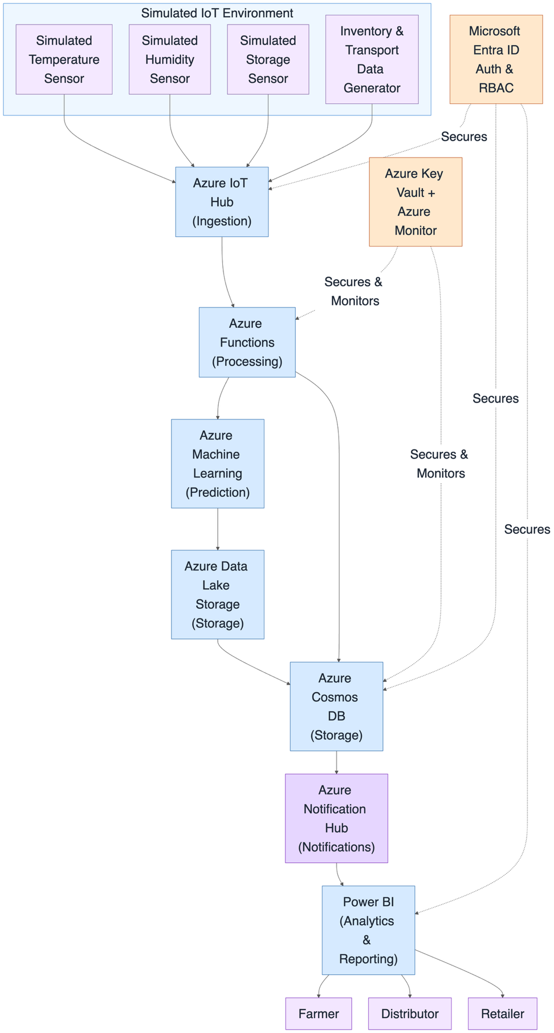

2. Complete System Architecure
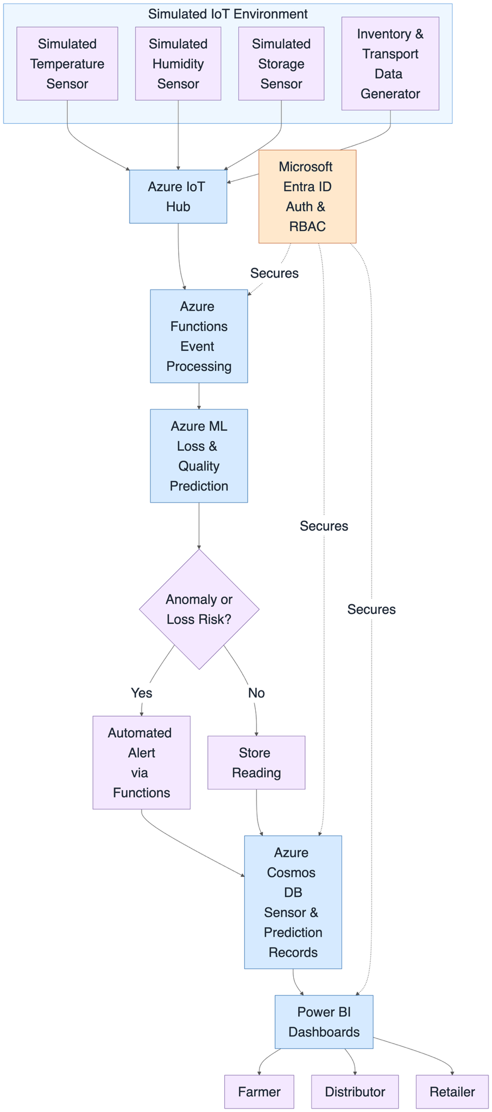

Dataset Details
- Dataset Name: FAO Food Loss and Waste (FLW) Database
- Source: Food and Agriculture Organization of the United Nations (FAO), Food Loss and Waste Database
- URL: https://www.fao.org/platform-food-loss-waste/flw-data/ (hosted via FAO's R Shiny data explorer, foodandagricultureorganization.shinyapps.io/FoodLoss)
- Size: 30,361 records
- Number of Records: 30,361
- Number of Features: 9 (country, region, commodity, year, loss_percentage, food_supply_stage, activity, cause_of_loss, method_data_collection)
- Data Type: Text, Structured, Tabular CSV file.
- License: FAO Open Data license (CC BY-NC-SA 3.0 IGO) — free to use with attribution, non-commercial
- Purpose of Using the Dataset: Used as a real-world reference for food loss percentages across commodities and supply-chain stages, providing a grounding basis for the synthetic sensor/inventory dataset generated for model training in this project.
AWS Service Planning
Azure Service | Purpose in the Project
Azure IoT Hub | Ingest simulated sensor data (temperature, humidity, storage conditions) from the simulated IoT environment
Azure Functions | Process incoming sensor and inventory data in real time, trigger predictions and alerts on anomaly detection
Azure Machine Learning | Train, evaluate, and deploy the food loss and quality prediction model
Azure Data Lake Storage | Store raw and processed sensor, inventory, and transportation data at scale
Azure Cosmos DB | Store real-time sensor readings and prediction records for low-latency access
Microsoft Entra ID (Azure AD) | Secure authentication and role-based access for farmers, distributors, and retailers
Azure Key Vault | Securely store and manage secrets, connection strings, and API keys used across services
Azure Monitor | Monitor system health, performance, and availability of Functions and IoT Hub
Azure Notification Hub | Send automated alerts and recommendations to stakeholders when food loss or quality risk is detected
Power BI | Visualize inventory levels, loss predictions, and optimization recommendations through interactive dashboards
Azure App Service | Host the web-based dashboard/portal for stakeholders to access supply chain insights
Azure Virtual Network (VNet) | Secure internal communication between Azure services within a private network

